**1.Total_Sales**

SELECT

SUM(Line_Total) AS TotalSales

FROM

Sales_Order;

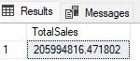

**2. Total_Profit**

SELECT

SUM(Line_Total - Total_Unit_Cost) AS TotalProfit

FROM

Sales_Order;

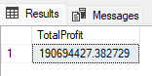

**3.Budget Utilization**

SELECT

P.Product_Name,

SUM(SO.Line_Total) AS TotalSales,

B._2017_Budgets AS Budget2017,

(SUM(SO.Line_Total) / B._2017_Budgets) * 100 AS BudgetUtilizationPercentage

FROM

Sales_Order SO

JOIN

Products P ON SO.Product_Description_Index = P.[Index]

JOIN

[2017_Budgts] B ON P.Product_Name = B.Product_Name

GROUP BY

P.Product_Name, B._2017_Budgets

ORDER BY

TotalSales DESC;

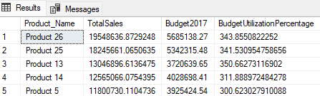

**4. Sales Growth**

WITH YearlySales AS (

SELECT

YEAR(OrderDate) AS SalesYear,

SUM(Line_Total) AS TotalSales

FROM

Sales_Order

GROUP BY

YEAR(OrderDate)

)

SELECT

SalesYear,

TotalSales,

LAG(TotalSales) OVER (ORDER BY SalesYear) AS PreviousYearSales,

(TotalSales - LAG(TotalSales) OVER (ORDER BY SalesYear)) * 100.0 /

LAG(TotalSales) OVER (ORDER BY SalesYear) AS SalesGrowthPercentage

FROM

YearlySales

ORDER BY

SalesYear;

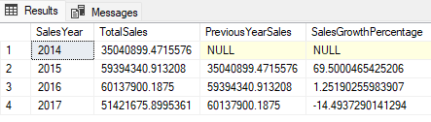

**5.Sales by Region**

SELECT

R.Full_Name AS RegionName,

SUM(SO.Line_Total) AS TotalSales

FROM

Sales_Order SO

JOIN

Regions R ON SO.Delivery_Region_Index = R.[Index]

GROUP BY

R.Full_Name

ORDER BY

TotalSales DESC;

